Report for consumo irregular por relleno de piscina

1. Time Series Characterization
Mean consumption: 144.94430379746836
Median consumption: 39.0
Std deviation: 496.6938888541766
Minimum consumption: 0
Maximum consumption: 9014
95th percentile: 461.0
Total records: 395
Above Normal deviations: 23
Below Normal deviations: 0

2. Consumption Line Plot
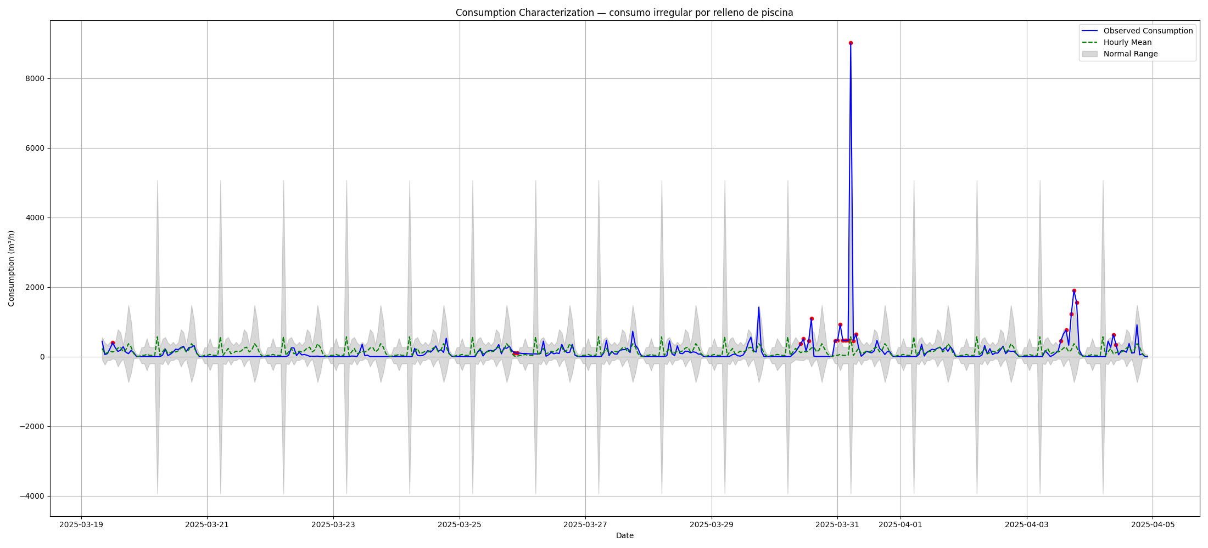

3. Deviation Heatmap
